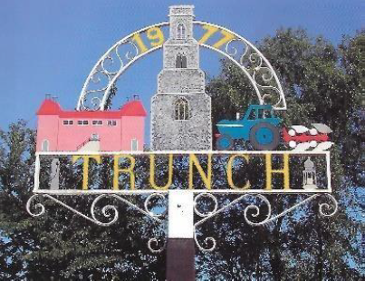
TRUNCH ANNUAL PARISH COUNCIL MEETING
TO BE HELD ON TUESDAY 8th July 2025 AT 7PM IN TRUNCH VILLAGE HALL, KNAPTON ROAD, TRUNCH, NR28 0QE

Councillors are summoned to, and members of the public and press are invited to attend. At item 5 the public will be invited to give their views and questions to the Parish Council on issues on the agenda or raise issues for the consideration of inclusion at future meetings. This item will generally be limited to a 30 minutes duration and will first include County/District Councillors and Police reports.
Tracy Neave Clerk to Trunch Parish Council 26th June 2025

AGENDA

- To discuss Cllr Miles intention to resign as Chair and appoint replacement, to appoint Vice Chair and sign acceptance of office forms

- Apologies for absence

- To receive declarations of interest for items on the agenda and to consider any requests
for dispensation

- To confirm the Minutes of the meeting held on 10th June 2025

5. Public Participation
5.1 County Councillors report – Councillor Maxfield’s report circulated via email
5.2 District Councillors report
5.3 Public Participation

6. Correspondence
6.1 Grant information regarding goalposts

7. Matters Arising from previous minutes and new items.
7.1 Parish Partnership Scheme
7.2 Feedback from Clerk appraisal including council communications

8. Finance and Administration
8.1 Bank statements and bank reconciliation: no bank statement available at time
Of advertising agenda
8.2 Payment schedule: Payments to be authorised and any late payments
30.6.25 NALC training £42.00
30.6.25 TT Jones £55.36
30.6.25 Clerk salary £560.71
30.6.25 Clerk expenses £57.04

8.3 To update bank mandate in respect of Chairperson and review bank signatories

9 Highways
9.1 To receive any Highways matters and agree actions

10. Playing Field: to receive any playing field matters and agree actions including working
group recommendations
10.1 Update on fencing issue
10.2 Play area inspection training
10.3 Any other issues

11. Planning
11.1 New Planning Applications
11.2 Decisions
11.3 Appeals

12 To receive a report and consider any actions
12.1 Allotments including extending tenancy to a six-year term
12.2 Community Speed
12.3 Neighbourhood Plan
12.4 Good Neighbour Scheme
12.5 Environmental Group
12.6 Footpaths

13. General Parish Issues (for information only)
The October meeting will be held at Trunch Methodist Hall

14. Date of next Parish Council Meeting 9th September 2025 7pm Trunch Village Hall

