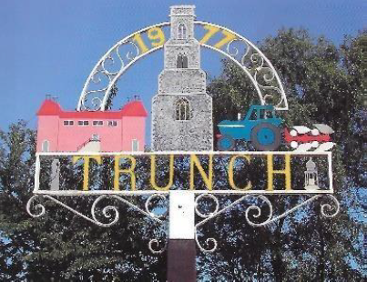
TRUNCH PARISH COUNCIL MEETING
TO BE HELD ON TUESDAY 10th December 2024 AT 7PM IN TRUNCH VILLAGE HALL, KNAPTON ROAD, TRUNCH, NR28 0QE

Councillors are summoned to, and members of the public and press are invited to attend. At item 5 the public will be invited to give their views and questions to the Parish Council on issues on the agenda or raise issues for the consideration of inclusion at future meetings. This item will generally be limited to a 30-minute duration and will first include County/District Councillors and Police reports.
Tracy Neave Clerk to Trunch Parish Council 5th December 2024
AGENDA

- Apologies for absence

- To receive declarations of interest for items on the agenda and to consider any requests for dispensations

4. To confirm the Minutes of the meeting held on Tuesday 12th November 2024

5. Public Participation
5.1 County Councillors report
5.2 District Councillors report
5.3 Public Participation

6. Correspondence
6.1 Norfolk Association Local Council Annual General Meeting

7. Matters arising from previous minutes
7.1 Age Friendly Norfolk
7.2 Trunch Village Hall Grounds Maintenance

8. New items
8.1 Clerks report

9. Periodic items
9.1 Tender for Grass Cutting

10. Finance
10.1 Bank statements and bank reconciliation
10.2 Income and Expenditure
10.3 Payment schedule: (Other late payments may be authorised)
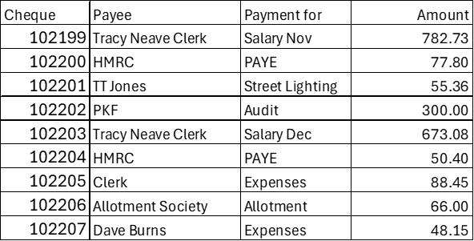

10.4 St James Trust
10.5 Setting the 2025/6 Budget/Precept

11. Highways
11.1 Highways Inspection Update and Actions: NTRO8842 affecting the Mundesley Road
from its junction with Back Street to its junction with Trunch Road 16-20 December
11.2 To receive any other Highways matters and agree action

12. Playing Field
12.1 To receive any playing field matters and agree actions
12.2 Results of annual external playing field inspection

13. Planning
13.1 New Planning Application: Nothing to report
13.2 Decisions: Nothing to report
13.3 Appeals: Nothing to report

14 Footpaths
14.1 To receive footpath matters and agree action

15 To receive a report and consider any actions
15.1 Allotments
15.2 Community Speed
15.3 Neighbourhood Plan
15.4 Good Neighbour Scheme
15.5 Warm Room
15.6 Environmental Group
15.7 Snappy Shopper

16. General Parish Issues (for information only)
16.1 Clerk annual leave 3rd to 18th January 2025

18. Date of next meeting: 14th January 2025

