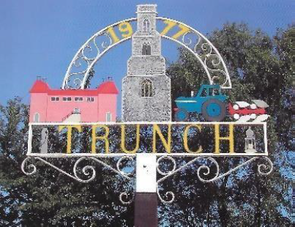
TRUNCH PARISH COUNCIL MEETING
TO BE HELD ON TUESDAY 9th April 2024
AT 7PM IN TRUNCH VILLAGE HALL, KNAPTON ROAD, TRUNCH, NR28 0QE

Councillors are summoned to, and members of the public and press are invited to attend. At item 5 the public will be invited to give their views and questions to the Parish Council on issues on the agenda or raise issues for the consideration of inclusion at future meetings. This item will generally be limited to a 30 minute duration and will first include County/District Councillors and Police reports.
Tracy Neave Clerk to Trunch Parish Council 4th April 2024
AGENDA

- Election of Chairperson and appointment of Vice-Chairperson

- Apologies for absence

3. To receive declarations of interest for items on the agenda and to consider any requests for dispensations

4. To confirm the Minutes of the meeting held on Tuesday 12th March 2024

5.Public Participation
5.1 County Councillors report distributed via email
5.2 District Councillors report
5.3 Public Participation

6. Correspondence
6.1 Transport East Survey
6.2 NALC weekly updates
6.3 Norwich Western Link Project Update
6.4 Rural Bulletin
6.5 Norfolk Marathon Road Closures
6.6 Norfolk Voice Bulletin
6.7 Environment Agency Mundesley Beck

7. Matters arising from previous minutes and to receive updates
7.1 Applied for DERS Bronze award
7.2 Update on Annual Parish Meeting

8. New items
8.1 Clerk’s report
8.2 Co-option of Parish Councillor
8.3 Communication and magazine
9. Periodic items
9.1 To formally adopt Policies
9.2 Annual Parish Meeting

10. Finance
10.1 Bank statements and bank reconciliation including March payments
10.2 Income and Expenditure
10.3 Payment schedule:
April Payments to be authorised up to meeting date
Cheque
102123 | SR Print and Design | Printing | -£84.00
102124 | NALC | Subscription | -£259.15
102125 | NPTS | Subscription | -£239.35
102126 | NPTS | Training | -£192.00
102127 | Zurich | Insurance | -£624.00
Direct Debit
 | Npower | Electricity | -£47.64

10.4 AGAR Form2 Exemption Certificate
10.5 Fixed assets

11. Highways
11.1 Highways Inspection Update and Actions
11.2 To receive any other Highways matters and agree action

12. Playing Field
12.1 Playing field and surveyupdate

13. Planning
13.1 New Planning Application:
13.1.1 NNDC Reconsultation PF/23/1580. Land East Of Lincoln Cottage, Trunch
13.1.2 PF/24/0592 - Trunch - Agricultural Barn, Brick Kiln Road, Trunch
13.2 Decisions
13.3 Appeals

13 Footpaths
13.1 To receive footpath matters and agree action

15 To receive a report and consider any actions
15.1 Allotments
15.2 Community Speed
15.3 Neighbourhood Plan
15.4 Good Neighbour Scheme
15.5 Warm Room

16. General Parish Issues (for information only)

17.Confirm date of next Parish Council Meeting

