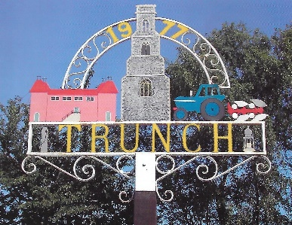 Trunch Parish Council
2022
To all Members of the Council
You are hereby summoned to attend the Ordinary Meeting of the Trunch Parish Council to be held on 7th September 2022 at the Methodist Church at 7.30pm we will need all Councillors to attend for the purpose of transacting the following business.

AGENDA

- APOLOGIES FOR ABSENCE AND TO RECEIVE A RESIGNATION

- DECLARATIONS OF INTEREST AND REQUESTS FOR DISPENSATIONS

- MINUTES OF THE MEETINGS HELD ON 6th July 2022 and MATTERS ARISING.

- COUNTY AND DISTRICT COUNCILLORS REPORT
4.1 County Councillors report
4.2 District Councillors report

- PUBLIC PARTICIPATION

- FINANCE MATTERS
6.1 To agree the cheques for payment
  - To agree and late Invoice payment requests
6.3 Monthly figures for June and July 2022
6.4 To consider any other financial matters and agree action.

7 Parish Plan
7.1 Parish Action Plan – Update from August working party meeting.
7.2 To develop and agree a mission, vision, aims and objectives for the Parish Council.
7.3 Emergency Plan – to set up a working party to include, TVS, Church and other interested parties
7.4 Preparation for May 2023 Elections.

8. HIGHWAYS
8.1 20mph limit – to receive an update from the Chairman
8.2 To receive any other Highways matters and agree action
.
9 PLAYING FIELD
9.1 Public Space Protection Order – Clerk to update
9.2 Registering of Title – to receive update.
9.3 Tree planting on the playing field – to agree actions
9.4 To receive other playing field matters and agree actions.

- PLANNING
10.1 To receive update on Planning Applications and agree actions:
  - Local Plan – Nutrient Neutrality - to receive an update
10.3 To receive any other Planning matters and agree actions.

11 FOOTPATHS
11.1 Verge Cutting costs – to receive information and agree action.
11.2 To receive footpath matters and agree action

- TASK AND FINISH GROUP
12.1 Allotments – To receive update and agree actions

- PARISH MATTERS
13.1 Trunch Village Society - Questionnaire– to receive an update
13.2 Inspection of Assets – to receive an update
13.3 Broadband - Trunch Fibre to The Premises (FTTP) Initiative – to receive update.
13.4 Cemetery Gates – to receive update
13.5 Village Hall – to receive any updates
13.6 Empty Homes – to receive an update
  - Village Shop/post office Closure – to discuss and agree actions
  - Cost of Living – actions and grants
  - Civility and Respect – Clerk to provide update
13.10 Reducing numbers of Parish Councillors to 9/7 – clerk to update
13.11 Other Parish Matters

14 NORFOLK ALC – WELLBEING INITATIVE
  - Various papers - circulated for information

15 CORRESPONDENCE
  - Norfolk ALC Bulletin – circulated for information
15.2 Correspondence – circulated for information

Next Meeting: October 5th, 2022, at Methodist Church at 7.30pm

