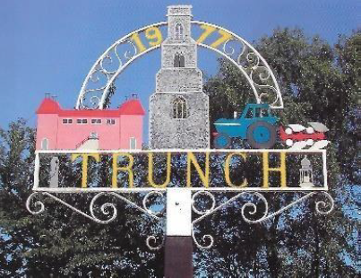
TRUNCH PARISH COUNCIL MEETING
TO BE HELD ON TUESDAY 14th January 2025 AT 7PM IN TRUNCH VILLAGE HALL, KNAPTON ROAD, TRUNCH, NR28 0QE

Councillors are summoned to, and members of the public and press are invited to attend. At item 5 the public will be invited to give their views and questions to the Parish Council on issues on the agenda or raise issues for the consideration of inclusion at future meetings. This item will generally be limited to a 30-minute duration and will first include County/District Councillors and Police reports.
Tracy Neave Clerk to Trunch Parish Council 2nd January 2025
AGENDA

- Apologies for absence

- To receive declarations of interest for items on the agenda and to consider any requests for dispensations

4. To confirm the Minutes of the meeting held on Tuesday 10th December 2024

5. Public Participation
5.1 County Councillors report
5.2 District Councillors report
5.3 Public Participation

6. Correspondence
6.1 Unity Trust banking – queries with initial set up

7. Matters arising from previous minutes
7.1Trusteeship MADRAC (Knapton)

8. New items
8.1 Nothing to report

9. Periodic items
9.1 Tender for Grass Cutting sent

10. Finance
10.1 Bank statements and bank reconciliation
10.2 Income and Expenditure
10.3 Payment schedule: (Other late payments may be authorised)

10.4 St James Trust – application to close account submitted
10.5 Setting the 2025/6 Budget/Precept

11. Highways
11.1 Highways Inspection Update and Actions: NTRO955 Gimmingham emergency
notification
11.2 To receive any other Highways matters and agree action

12. Playing Field
12.1 To receive any playing field matters and agree actions
12.2 Results of annual external playing field inspection – set working group to discuss inspection workload

13. Planning
13.1 New Planning Application: Nothing to report
13.2 Decisions: PO/24/0716 Land Off Bradfield Road, Trunch Construction of 6 self-build
dwellings (outline with details of access only): refused
13.3 Appeals: Nothing to report

14 Footpaths
14.1 To receive footpath matters and agree action

15 To receive a report and consider any actions
15.1 Allotments
15.2 Community Speed
15.3 Neighbourhood Plan
15.4 Good Neighbour Scheme
15.5 Warm Room
15.6 Environmental Group including proposals from recent working group meeting
15.7 Snappy Shopper

16. General Parish Issues (for information only)

17. Date of next meeting: 11th February 2025

