Minutes of Trunch Parish Council Meeting
Held on Tuesday 10th December at 7pm

Present: Cllr. Richard Miles (Chair), Cllrs. Gaynor Houlton, David Burns, Malcolm Bulley Jeremy Fielding, Peter Neatherway, Ed Maxfield, Parish Clerk Tracy Neave, five Members of the Public

- Apologies for absence: Cllr Paul Pearson; David Houlton, Barbara Wilson, Ed Maxfield

- Declarations of interest and requests for dispensations
Cllr Wilson: Allotment Holder

- Minutes of previous meeting held on 12th November 2024 were agreed and signed by the Chairperson.

- Public Participation
  - County Councillor’s report: see appendix 1
  - District Councillor’s report: Cllr. Neatherway reported a possibility of attendance of colleague at January meeting to discuss the questions raised concerning the Local Plan, specifically the confusion of the increased number of expected new houses and the definition of ‘infill’. Current issues being dealt with are homelessness, budgeting and parking issues on Cornish Avenue.
  - Public Participation: Concerns were raised over local road works. Clerk still not receiving some traffic notifications and District Councillor will raise this. A member of the public asked if the playing field could be utilised more for events and raised the state of the gate which is in need of repair.

- Correspondence:
  - Norfolk Association Local Council Annual General Meeting: awaiting minutes

6 Matters arising from previous minutes
6.1 Age Friendly Norfolk: nothing to report
6.2 Trunch Village Hall Grounds Maintenance to be undertaken by Richard Miles on behalf of the Committee

7 New items
7.1 Clerks Report: Clerk had HR review with Cllrs G Houlton and Bulley and an allotment meeting with Cllrs G and D
Houlton. The Clerk had attended planning training organised by NPTS and Clerks Networking session. Currently
working on local service agreement for verge cutting and budget. The application to move to Unity Bank has been
submitted. The council agreed that the Clerk could ask B H Accounting Services to undertake the external audit for
financial year 2024/5. The Clerk had received a visit at her home from MADRA Concerned Neighbour Group, who
requested she pass correspondence to the Chairperson.

8. Periodic items
8.1 The tender for grass cutting has been reviewed and is being prepared to send out for invite to tender. Review
showed that RB10/11 is cut once a year and agreed to move to two cuts. Some of the churchyard will be set to
wildflowers and not require cutting.

9. Finance
9.1 Bank statements and bank reconciliation agreed with statements signed by Cllr Miles. See appendix 2
9.2 Income and Expenditure: see appendix 3
9.3 Payment schedule: see appendix 4 no late payments

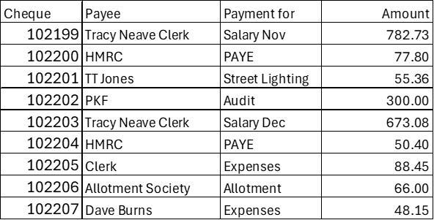

9.4 Agreed to close St James Trust account and form signed for authorisation.
9.5 Setting the Budget and Precept 2025/2026. There has been no decision and there will be another finance
working group meeting. The Clerk asked if the work detailed in the recent playing field inspection has been
accounted for in the budget.

10. Highways
10.1 Highways Inspection Update and Actions: NTRO8842 affecting the Mundesley Road from its junction with Back
Street to its junction with Trunch Road 16-20 December

11. Playing Field
11.1 Agreed to use same external inspector next year and clerk to organise. The work from the recent inspection
needs to be organised.

12. Planning
12.1: Planning Application: nothing to report
12.2 Decisions: noting to report
12.3 Appeals: nothing to report

12 Footpaths: Dog waste bins are not being emptied as per schedule. Clerk to advise Cllr Neatherway of schedule
and he will take further.

13. To receive a report and consider any actions
13.1 Allotments: Agreed to increase allotment rentals by 20%. Inspection will take place in March.
13.2 Community Speed: Good comments received at the local SNAP meeting as to how effectively the Trunch
Community Speed team are organised.
13.3 Neighbourhood Plan: Application submitted and awaiting decision with reference to application for a grant
for use for professional advice.
13.4 Good Neighbour Scheme: continues to work well with 23 requests in last month, and a befriending service.
13.5 Warm Room: good attendance with low cost to council due to using previous grant monies.
13.6 Environmental Group: to have first meeting this month.
13.6 Snappy Shopper: an easy to use service available by phone and internet app.

14. General Parish Issues
14.1 Clerk on annual leave 3rd to 18th January 2025.

15. Date of next meeting 14th January 2025 at 7pm at Trunch Village Hall

Meeting closed at 8pm

Appendix 1:
County Councillor’s Report
December 2024
Norwich Western Link
I thought it was worth sharing the County Council’s press release on this in full:
The Leader of Norfolk County Council Cllr Kay Mason Billig has written to government Ministers to tell them their assistance is needed to positively resolve an “impossible position” the council finds itself in on its priority Norwich Western Link project.
In March this year, days before the planning application for the Norwich Western Link was due to be submitted, Natural England published updated guidance on barbastelle bats, which are present in the area around the proposed route of the new 3.9 mile dual carriageway road to the west of Norwich. As a result, the council now has a significant impediment to being able to deliver the project.
A report that is due to be considered by Norfolk County Council’s cabinet on Monday 2 December provides an update on the project, including the ongoing liaison between the council and Natural England, which has not resolved the matter.
In light of this, and as it would not have been possible for the council to take the updated barbastelle bat guidance into account before it was published, the council has urged the Secretary of State for Transport and the Secretary of State for the Environment, Food and Rural Affairs to urgently review the issue. The letter also asks them to intervene in order to resolve this issue positively for the people and businesses of Norfolk.
Cllr Graham Plant, Cabinet Member for Highways, Transport and Infrastructure at Norfolk County Council, said: “We want to deliver important infrastructure improvements like the Norwich Western Link but, despite our best efforts, we find ourselves in an impossible position.
“The Norwich Western Link was made a priority infrastructure project for the council in 2016, and advice from Natural England has informed our proposals from its early stages. Last year, we were in a good position, having secured Outline Business Case approval from the Department for Transport, and they have backed the project with significant development funding. But we are now caught between government policies and systems, and need them to intervene to find a good solution.
“The Government has suggested that it is committed to enabling growth and to removing barriers in our planning system. We are therefore hopeful that they will help us to reach a positive outcome.”
In the letter to Ministers, Cllr Mason Billig writes: “The ability for a statutory environmental agency to shift the goal posts so significantly and immediately is a potential barrier to any and all future development, and therefore our experience with the Norwich Western Link should not be seen as an isolated case.”
While responses to letters to both Natural England and government Ministers, and the outcome of the Government’s spending review of transport schemes, are awaited, the report recommends reducing spending, by reducing or pausing activity on the project, including closing out Stage 1 of the design and build contract with Ferrovial Construction and descoping future stages from the current contract. The report also recommends that a further update report is received by cabinet once there is more clarity on Natural England’s and the Government’s consideration of the issue.
The report will be considered by Norfolk County Council’s cabinet on Monday 2 December. The letters from the council to government Ministers and Natural England are appended to the report. You can watch the meeting, live or afterwards, and read the reports online.
About the Norwich Western Link
The Norwich Western Link is a 3.9 mile dual carriageway road that would connect the A47 to Broadland Northway to the west of Norwich. Together with the upgraded A47 between North Tuddenham and Easton the new road would complete a fully dualled orbital route around the city.
The Norwich Western Link would take traffic off unsuitable local roads and out of communities. As a result, benefits the new road is expected to realise include:
• A boost to economic growth in Norfolk, for the ambitions and profitability of our existing businesses but also our attractiveness to investors and entrepreneurs as a place to do business.
• Shorter and more reliable journey times to key sites around Norwich, including the Norfolk and Norwich University Hospital, the University of East Anglia, Norwich Airport and the Food Enterprise Park.
• Taking traffic off local roads and communities would lead to improved air quality near where people live and would support people to walk and cycle.
• Improvements to road safety and a reduction in collisions as traffic transfers onto a higher-standard, dual carriageway route.
Norfolk County Council secured Outline Business Case approval for the Norwich Western Link from the Department for Transport (DfT) in October 2023 and with it a £213 million funding commitment, subject to gaining relevant statutory approvals. To date, we have received £33 million of development funding from DfT.

Appendix 2
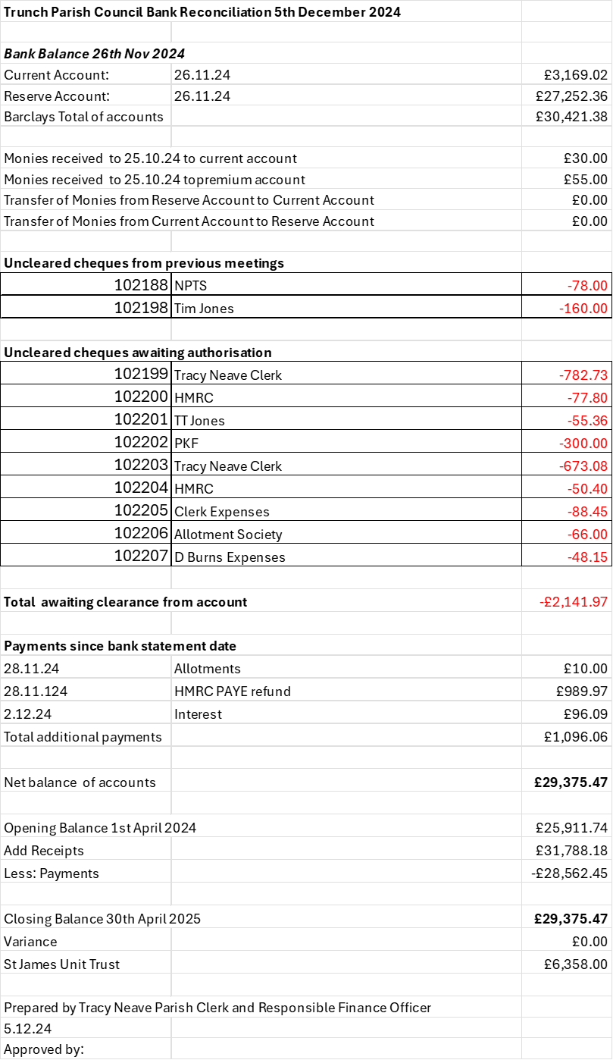
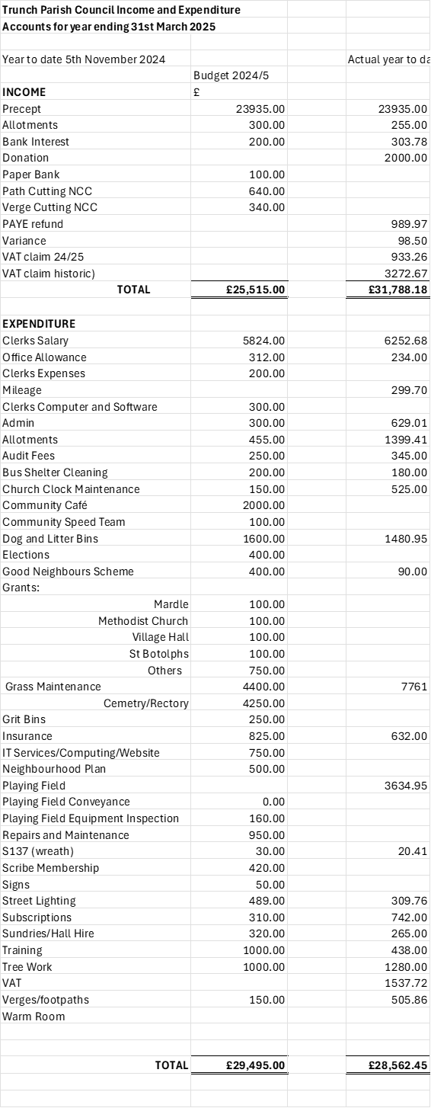
Appendix 3

