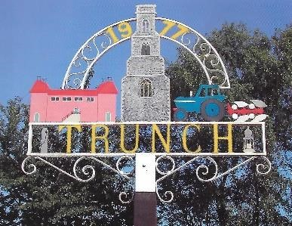 Trunch Parish Council
2023
To all Members of the Council
You are hereby summoned to attend the Ordinary Full Council Meeting of the Trunch Parish Council to be held on 6th September 2023 at the Methodist Church at 7.30pm we will need all Councillors to attend for the purpose of transacting the following business.

AGENDA

- APOLOGIES FOR ABSENCE

- DECLARATIONS OF INTEREST AND REQUESTS FOR DISPENSATIONS

- MINUTES OF THE MEETINGS HELD ON 7TH JULY 2023 and MATTERS ARISING.

4. COUNTY AND DISTRICT COUNCILLORS REPORT
4.1 County Councillors report
4.2 District Councillors report

5. PUBLIC PARTICIPATION

6. FINANCE MATTERS
6.1 To agree the cheques for payment.
6.2 To agree any late Invoice payment requests
  - Monthly figures for July 2023

7. HIGHWAYS
7.1 Highways Inspection
7.2 To receive any other Highways matters and agree action

8 PLAYING FIELD
8.1 Cost to replace the broken handrail and agree actions - Clerk to update
8.2 To arrange for Tree works – Clerk to update
8.3 To receive other playing field matters and agree actions.

9 PLANNING
9.1To receive update on Planning Applications and agree actions:
To ratify the decision on the following application due to time constraints –
PF/23/1531 Mayfield, Trunch Road – PC objected to the application.
9.2 To receive any other Planning matters and agree actions.

FOOTPATHS
10.1 Southrepps Path – Clerk to update
10.2 To receive footpath matters and agree action

11TASK AND FINISH GROUP
11.1 Allotments – To receive update and agree actions

12 PARISH MATTERS
12.1 Proposal to adopt the Trunch 2023 Vision statement and associated priorities
12.2 To produce and then to adopt a PC communications framework (Style, Brand and Tone focused)
12.3 Proposal to explore a secure email for Trunch PC with new emails for councillors.
12.4 Community Speed watch
12.5 Speeding in villages
12.6 Parish Meeting to discuss the views of the village.
12.7 Dates of Full parish meetings – Clerk to update.
12.8 Other Parish Matters – change of date and day of Full Council meeting

13 NORFOLK ALC – WELLBEING INITATIVE
13.1 Update to be given

14 CORRESPONDENCE
14.1 Norfolk ALC Bulletin
14.2 Correspondence – none

15 TO CONSIDER A REOLUTION UNDER THE PUBLIC BODIES ACT (ADMISSIONS TO MEETINGS ACT 1960) TO EXCLUDE MEMBERS OF THE PUBLIC

15.1 Personnel Matters

Next Meeting 4th October 2023 at 7.30pm Methodist Church

