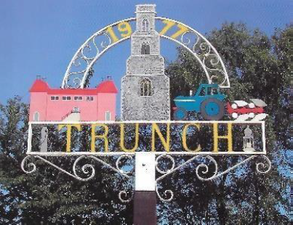
TRUNCH PARISH COUNCIL MEETING
TO BE HELD ON TUESDAY 12th March 2024
AT 7PM IN TRUNCH VILLAGE HALL, KNAPTON ROAD, TRUNCH, NR28 0QE

Councillors are summoned to, and members of the public and press are invited to attend. At item 4 the public will be invited to give their views and questions to the Parish Council on issues on the agenda or raise issues for the consideration of inclusion at future meetings. This item will generally be limited to a 30 minute duration and will first include County/District Councillors and Police reports.
Tracy Neave Clerk to Trunch Parish Council 8th March 2024

AGENDA

1. Apologies for absence

2. To receive declarations of interest for items on the agenda and to consider any requests for dispensations

3. To confirm the Minutes of the meeting held on 13th February 2024

4.Public Participation
4.1 County Councillors report (February 2024 report received via email)
4.2 District Councillors report
4.3 Tim Payne Church Warden

5. Correspondence
5.1 NALC newletter sent via email
5.2 NALC Chief Executive Bulletin sent via email
5.3 NCF Funding and Support bulletin sent via email
5.4
5.5
5.6
5.7

6. Matters arising from previous minutes and to receive updates

7. New items
7.1 Clerk’s report
7.2 Training
7.3 Orsted 3 Community Fund
7.4 Blister Pack Recycling

8. Periodic items
8.1 To formally adopt Policies

9. Finance
9.1 Bank statements and bank reconciliation
9.2 Income and Expenditure
9.3 Payment schedule
9.4 Internal Audit Update

10. Highways
10.1 Highways Inspection Update and Actions
10.2 To receive any other Highways matters and agree action

11. Playing Field
11.1 To receive any playing field matters and agree actions.

12. Planning
12.1 New Planning Applications and agree actions
12.2 Decisions
12.3 Appeals

13 Footpaths
13.1 To receive footpath matters and agree action

14 To receive a report and consider any actions
14.1 Allotments
14.2 Community Speed
14.3 Neighbourhood Plan
14.4 Good Neighbour Scheme
14.5 Warm Room

15. General Parish Issues (for information only)

16. Set date of next Parish Council Meeting

