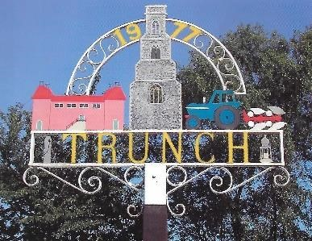 Trunch Parish Council
2023
To all Members of the Council
You are hereby summoned to attend the Annual Parish Meeting followed by an Ordinary Full Council Meeting of the Trunch Parish Council to be held on 10th May 2023 at the Methodist Church at 7.30pm we will need all Councillors to attend for the purpose of transacting the following business.

AGENDA
- Welcome

- Report from Outgoing Chairman

- Introduction to Councillors

- Elections of a Chairman and signing of the Declaration of Office

- Discussion on Induction

AGENDA

- APOLOGIES FOR ABSENCE

- DECLARATIONS OF INTEREST AND REQUESTS FOR DISPENSATIONS

- MINUTES OF THE MEETINGS HELD ON 5th APRIL 2023 and MATTERS ARISING.

4. COUNTY AND DISTRICT COUNCILLORS REPORT
4.1 County Councillors report
4.2 District Councillors report

5. PUBLIC PARTICIPATION

6. FINANCE MATTERS
6.1 To agree the cheques for payment.
6.2 To agree any late Invoice payment requests
6.3 Monthly figures for March 2023
6.4 To discuss Annual Governance Annual Return – Clerk to update

8. HIGHWAYS
8.1 Highways Inspection
8.2 To receive any other Highways matters and agree action

9 PLAYING FIELD
9.1 To receive other playing field matters and agree actions.

10 PLANNING
10.1To receive update on Planning Applications and agree actions:
PF/23/0870 Trunch Corner Stores Gimingham Road Trunch North Walsham Norfolk NR28 0PS - Proposed alterations to winidows & doors on front façade.
PF/23/0613 The Roost Mundesley Road Trunch North Walsham Norfolk NR28 0QB - Detached dwelling, cartshed and associated works
10.2 To receive any other Planning matters and agree actions

11 FOOTPATHS
11.1 Verge Cutting – Clerk to update on current situation.
11.2 Southrepps Path – Clerk to update
11.3 To receive footpath matters and agree action

- TASK AND FINISH GROUP
12.1 Allotments – To receive update and agree actions

13 PARISH MATTERS
13.1 Kings Coronation Event – Chairman to update
13.2 Other Parish Matters

14 NORFOLK ALC – WELLBEING INITATIVE
14.1Various papers - circulated for information

15 CORRESPONDENCE
15.1 Norfolk ALC Bulletin – circulated for information
15.2 Correspondence – none

Next Meeting: TBC 2023 at 7.30pm

