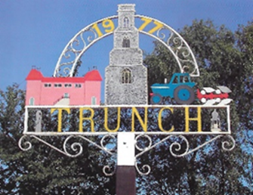

Trunch Parish Council
Minutes of Annual Parish Meeting
Held on 6th May 2024 at 6pm at Trunch Village Hall

Present: Cllrs Richard Miles (Chairman), David Burns, Jeremy Fielding, David Houlton, Gaynor Houlton, Paul Pearson, Barbara Wilson, Parish Clerk Tracy Neave, 37 Members of the Public

- The Chairman opened the meeting welcoming everyone to the meeting. There were no apologies for absence.

- Minutes of the Annual Parish Meeting held on 10th May 2023 were agreed and signed by the
Chairman.

- There were no matters arising from the previous minutes. Declarations of interest: Cllr Miles
re Village Hall.

- The Chairman’s report: Cllr Miles thanked the previous Chairman John Jones for his work involved in the Parish Council and Village Hall. The Chair thanked the Councillors and Clerk for their work.

- Presentation by Parish Council: There was a detailed presentation by the Council regarding work achieved over the last year and future plans.

Presentation by Village Hall Committee

- Questions from the Public:
  - Why were there a pile of pallets in the Village Hall Carpark? It was explained these are for part of a water management system and will be removed to the allotment area.
  - The lack of amenities was raised in the village, the Council will investigate how these can be improved.
  - Is the pub closing? The Council are not aware of intention to close the pub.
  - The Samsign speed device has been moved by the team.

- Date and time of next Annual Parish Meeting to be confirmed.

- The meeting closed at 1905 pm.

Refreshments were served.

