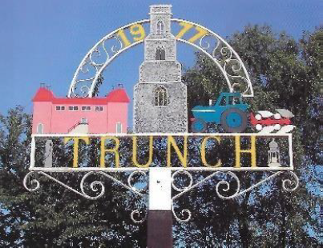
TRUNCH PARISH COUNCIL MEETING
TO BE HELD ON TUESDAY 10th September 2024
AT 7PM IN TRUNCH VILLAGE HALL, KNAPTON ROAD, TRUNCH, NR28 0QE

Councillors are summoned to, and members of the public and press are invited to attend. At item 5 the public will be invited to give their views and questions to the Parish Council on issues on the agenda or raise issues for the consideration of inclusion at future meetings. This item will generally be limited to a 30 minute duration and will first include County/District Councillors and Police reports.
Tracy Neave Clerk to Trunch Parish Council 5th September 2024
AGENDA

- Apologies for absence
- Co-option of Parish Councillor
- To receive declarations of interest for items on the agenda and to consider any requests for dispensations

4. To confirm the Minutes of the meeting held on Tuesday 9th July 2024

5. Public Participation
5.1 County Councillors report August sent via email
5.2 District Councillors report
5.3 Public Participation

6. Correspondence
6.1 Website received two comments regarding roadworks

7. Matters arising from previous minutes
7.1 Feedback from Environmental presentation and discuss proposal to set up
Environmental and Sustainability Group

8. New items
8.1 Clerk’s report: proposal regarding review of hours and feedback regarding workload,
Insurance claim,
8.2 Banking account – Barclays: discuss move to alternative bank
8.3 Affordable housing North Norfolk
8.4 Parish Online Mapping

9. Periodic items
9.1 Asset Inspection
9.2 Review of plans and projects for next six months

9.3 Parish Partnership bid
9.4 Marathon 13th April 2025

10. Finance
10.1 Bank statements and bank reconciliation
10.2 Income and Expenditure
10.3 Payment schedule: (Other late payments may be authorised)

10.4 HMRC PAYE overpayment
10.5 St James Trust

11. Highways
11.1 Highways Inspection Update and Actions: continual notice of closures in respect of
Internet cabling
11.2 To receive any other Highways matters and agree action

12. Playing Field
12.1 To receive any playing field matters and agree actions

13. Planning
13.1 New Planning Application: nothing to report
13.2 Decisions:
- NP/24/1546 Prior notification: Prior approval not required agricultural Hall
Farm Mundesley Road: erection of building agricultural use
- EF/24/1413 7 Church Close Trunch Certificate of Lawfulness- permission not
required: change of use
- PF/24/1105 Gorrell Hill Farm erection of two bay garage approved

13.3 Appeals: AP/24/0012 The Roost, Mundesley Road, Trunch, Norfolk, NR28 0QB
Construction of two-bedroom detached dwelling, cart shed garage and associated
works

14 Footpaths
14.1 To receive footpath matters and agree action

15 To receive a report and consider any actions
15.1 Allotments
15.2 Community Speed
15.3 Neighbourhood Plan
15.4 Good Neighbour Scheme
15.5 Warm Room/Community Cafe

16. General Parish Issues (for information only)
Clerk on annual leave 21st to 28th September

17. Date of next meeting: 8th October 2024

