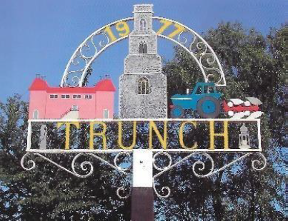

Minutes of Trunch Parish Council Extraordinary Meeting
Held on Wednesday 13th August Blacksmith Close Community Room at 8pm

Attend by: Cllrs Gaynor Houlton (Chair) David Houlton, Malcolm Bulley, Richard Miles, Alan Bowker David Burns one member of the public, Parish Clerk Tracy Neave

- Apologies Cllrs Karen Randell, Dave Shapcott, Charlie Yaxley

- There was a discussion to agree the response to the Planning Inspectorate regarding the proposed upgrade to Footpaths FP11 and 12 to a restrictred byway status. The Clerk to write a response on behalf of the Parish Council outlining the objection to the proposal. Points raised:

- Schedule misidentifies FP11 and FP12 completely as FP11
- States it is 6m wide: inaccurate and impassable in places
- Query as to any physical site surveys undertaken since application completed
- Concern as maintenance would be the responsibility of the parish council and could mean significant increase in Precept
- Parish Council unable to cover the cost of reinstating the byway
- Concern on environmental impact
- Council would be willing to reconsider the application being restricted to a smaller portion as a restricted byway

- Playing field: Petanque court and maintenance basketball hoop
- Proposal for new basketball hoop: agreed
- Petanque court: A grant of £1575 is available as a contribution towards a pétanque court at the playing field. Quotes obtained from Nick Hurst (Workforce) £5000 and Dunham Groundworks £3150 exc VAT. Unanimously agreed to contract Dunham Groundworks to undertake the work

- Matters for future meeting:
- FP5. A member of the public advised his concern over footpath FP5 which falls short at South Repps.
- Discrepancies between service delegation Norfolk County Council and contractual agreement for grass cutting

- Date of next Parish Council Meeting 9th September 2025 7pm Trunch Village Hall

Meeting closed 1952pm

