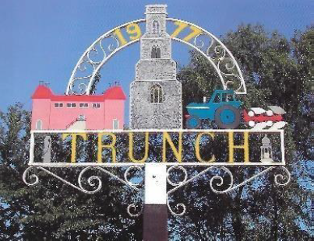
TRUNCH PARISH COUNCIL MEETING
TO BE HELD ON TUESDAY 11th June 2024
AT 7PM IN TRUNCH VILLAGE HALL, KNAPTON ROAD, TRUNCH, NR28 0QE

Councillors are summoned to, and members of the public and press are invited to attend. At item 5 the public will be invited to give their views and questions to the Parish Council on issues on the agenda or raise issues for the consideration of inclusion at future meetings. This item will generally be limited to a 30 minute duration and will first include County/District Councillors and Police reports.
Tracy Neave Clerk to Trunch Parish Council 6th June 2024
AGENDA

- Apologies for absence

2. To receive declarations of interest for items on the agenda and to consider any requests for dispensations

3. To confirm the Minutes of the meeting held on Tuesday 14th May 2024

4. Public Participation
4.1 County Councillors report distributed via email
4.2 District Councillors report
4.3 Public Participation

5. Correspondence
5.1 NALC weekly updates
5.2 Rural Bulletin
5.3 NALC Chief Executive updates
5.4 Volunteer Extravaganza notice
5.5 Community Matters
5.6 Priorities meeting update

6. Matters arising from previous minutes

7. New items
7.1 Clerk’s report

8. Periodic items
8.1 Nothing to report

9. Finance
9.1 Bank statements and bank reconciliation
9.2 Income and Expenditure
9.3 Payment schedule:

10. Highways
10.1 Highways Inspection Update and Actions
10.2 To receive any other Highways matters and agree action

11. Playing Field
11.1 To receive any playing field matters and agree action

12. Planning
13.1 New Planning Application: PO/24/0716 Erection of up to six dwellings (outline with
with details of access only) land off Bradfield Road, Trunch : object (TPC Planning
Committee decision as fell out of meeting timescale)
13.2 Decisions: PF/24/0592 Agricultural Barn, Brick Kiln Lane, Trunch: Approve full-
planning permission
13.3 Appeals: none

13 Footpaths
13.1 To receive footpath matters and agree action

14 To receive a report and consider any actions
14.1 Allotments
14.2 Community Speed
14.3 Neighbourhood Plan
14.4 Good Neighbour Scheme
14.5 Warm Room/Community Cafe

15. General Parish Issues (for information only)

16. Date of next meeting: 9th July 2024

