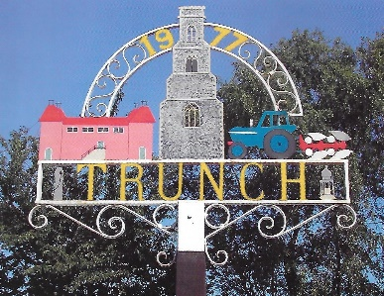 Trunch Parish Council
2023
To all Members of the Council
You are hereby summoned to attend the Ordinary Meeting of the Trunch Parish Council to be held on 4th January 2023 at the Methodist Church at 7.30pm we will need all Councillors to attend for the purpose of transacting the following business.

AGENDA

- APOLOGIES FOR ABSENCE

- DECLARATIONS OF INTEREST AND REQUESTS FOR DISPENSATIONS

- MINUTES OF THE MEETINGS HELD ON 7th December 2022 and MATTERS ARISING.

- TO HONOUR THE MEMORY OF COUNCILLOR PAUL TAYLOR – Council will hold a minutes silence

- COUNTY AND DISTRICT COUNCILLORS REPORT
5.1 County Councillors report
5.2 District Councillors report

- PUBLIC PARTICIPATION

- FINANCE MATTERS
7.1 To agree the cheques for payment.
7.2 To agree any late Invoice payment requests
7.3 Monthly figures for November 2022
7.4 To agree precept for 2023

8 Parish Plan
8.1 Emergency Plan – to set up a working party to include, TVS, Church and other interested parties – Chairman to update
8.2 Preparation for May 2023 Elections.

9. HIGHWAYS
9.1 Highways Inspection
9.2 To receive any other Highways matters and agree action

10 PLAYING FIELD
10.1 Tree planting on the playing field – to agree actions
  - To receive other playing field matters and agree actions.

- PLANNING
  - To receive update on Planning Applications and agree actions:
11.2 To receive any other Planning matters and agree actions

12 FOOTPATHS
12.1 Verge Cutting ongoing work for tender – Chairman to update.
12.2 Southrepps Path – Clerk to update
  - To receive footpath matters and agree action

13 TASK AND FINISH GROUP
  - Allotments – To receive update and agree actions

14 PARISH MATTERS
14.1 Kings Coronation Event – Chairman to update
14.2 Other Parish Matters

15 NORFOLK ALC – WELLBEING INITATIVE
  - Various papers - circulated for information

16 CORRESPONDENCE
16.1 Norfolk ALC Bulletin – circulated for information
16.2 Correspondence – circulated for information

Next Meeting: Full Council Meeting 1ST February 2023 at 7.30pm

