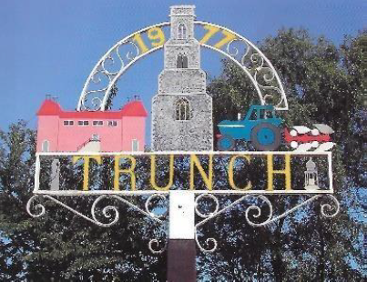
TRUNCH ANNUAL PARISH COUNCIL MEETING
TO BE HELD ON TUESDAY 13th MAY 2025 AT 730PM IN TRUNCH VILLAGE HALL, KNAPTON ROAD, TRUNCH, NR28 0QE

Councillors are summoned to, and members of the public and press are invited to attend. At item 6 the public will be invited to give their views and questions to the Parish Council on issues on the agenda or raise issues for the consideration of inclusion at future meetings. This item will generally be limited to a 30 minutes duration and will first include County/District Councillors and Police reports.
Tracy Neave Clerk to Trunch Parish Council 8th May 2025

AGENDA

- Apologies for absence

- Election of Chairman and appointment of Vice-Chair. Declarations of Acceptance of Office to be signed.

3. To receive declarations of interest for items on the agenda and to consider any requests for dispensations

4.To confirm the Minutes of the meeting held on 8th April 2025

- Co-option of Councillor David Shapcott

6. Public Participation
6.1 County Councillors report – Councillor Maxfield’s report circulated via email
6.2 District Councillors report

7. Correspondence
7.1 Invite to Town and Parish Council Event
7.2 Public consultation Dog Control
  - Nutrient Mitigation Fund
7.4 Planning Inspectorate ROW/3345919

8. Matters Arising from previous minutes and new items.
8.1 Defibrillator training advertised in Mardle: 7th July
8.2 Village Hall Grant request for car park repairs

9. Finance and Administration
9.1 Bank statements and bank reconciliation
9.2 Payment schedule
Payments to be authorised:
30.4.25 | Clerk Expenses | £55.54
30.4.25 | Clerk salary | £757.41
30.4.25 | HMRC | £15.60
30.4.25 | D Burns | £159.36
6.5.25 | S Hutcheson | £268.75
6.5.25 | Norfolk Training and Support | £156.00
6.5.25 | SR Print and Design | £42.00
6.5.25 | Woodpecker Tree Services | £500.00
6.5.25 | Tim Jones | £1,213.00

9.3 Asset Register
9.4 AGAR and Internal Auditor update
9.5 Delegation to Clerk
9.6 Continuation of General Power of Competence
9.7 Risk Register
9.8 S106 monies received

10 Highways
10.1 To receive any Highways matters and agree actions

11. Playing Field
11.1To receive any playing field matters and agree actions including working group
recommendations

12. Planning
12.1 New Planning Applications and agree actions
12.2 Decisions
12.3 Appeals

13 Footpaths
13.1 To receive footpath matters and agree action

14 To receive a report and consider any actions
14.1 Allotments
14.2 Community Speed
14.3 Neighbourhood Plan
14.4 Good Neighbour Scheme
14.5 Environmental Group

15. General Parish Issues (for information only)

16. Date of next Parish Council Meeting 10th June 2024 7pm Trunch Village Hall

