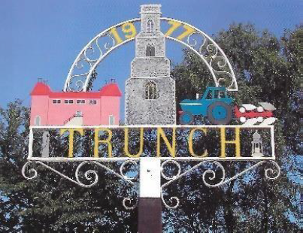
TRUNCH PARISH COUNCIL MEETING
TO BE HELD ON TUESDAY 11th March 2025 AT 7PM IN TRUNCH VILLAGE HALL, KNAPTON ROAD, TRUNCH, NR28 0QE

Councillors are summoned to, and members of the public and press are invited to attend. At item 5 the public will be invited to give their views and questions to the Parish Council on issues on the agenda or raise issues for the consideration of inclusion at future meetings. This item will generally be limited to a 30-minute duration and will first include County/District Councillors and Police reports.
Tracy Neave Clerk to Trunch Parish Council 6th February 2025
AGENDA

- Co-option of Parish Councillor Karen Randell

- Apologies for absence

- To receive declarations of interest for items on the agenda and to consider any requests for dispensations:

4. To confirm the Minutes of the meeting held on Tuesday 11th February 2025

5. Public Participation
5.1 County Councillor,s report
5.2 District Councillor’s report
5.3 Public Participation

6 Correspondence
6.1 Norfolk Marathon and Half Marathon
6.2 Letter regarding ownership of tree in recreation ground
6.3 Email saying rook scarers are frightening dogs and children

7. Resignation Parish Councillor Jeremy Fielding

8. Matters arising from previous minutes
8.1 S106 monies
8.2 Land ownership along footpath FP5

9. Policies and procedures
9.1 Financial Regulations
9.2 Standing Orders

10. Finance
10.1 Bank statements and bank reconciliation
10.2 Income and Expenditure
10.3 Payment schedule: (Other late payments may be authorised)

10.4 Request for annual 3% increase to playing field contract

11. Highways
11.1 Pothole project during February

12. Playing Field
12.1 To receive any playing field matters and agree actions
12.1 Proposal matting for path
12.2 Proposal scarify playing field and purchase of roller
12.3 Update on maintenance programme from Inspection report

13. Planning
13.1 New Planning Application: Nothing to report
13.2 Decisions: PF/24/2468 South Barn Mundesley Road, Trunch, NR28 0QB replacement
Of windows and doors on south elevation and first floor of east elevation: approved
13.3 Appeals:

14. Footpaths
14.1 To receive footpath matters and agree action

15 To receive a report and consider any actions
15.1 Allotments.
15.2 Community Speed
15.3 Neighbourhood Plan
15.4 Good Neighbour Scheme
15.5 Warm Room
15.6 Environmental Group

16. General Parish Issues (for information only)

17. Date of next meeting: 8th April 2025

