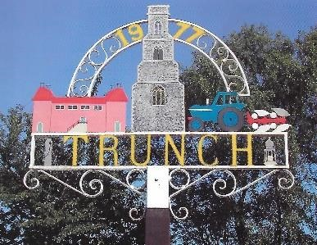 Trunch Parish Council
2023
To all Members of the Council
You are hereby summoned to attend the Annual Parish Meeting followed by an Ordinary Full Council Meeting of the Trunch Parish Council to be held on 4th October 2023 at the Methodist Church at 7.30pm we will need all Councillors to attend for the purpose of transacting the following business.

AGENDA

- APOLOGIES FOR ABSENCE

- DECLARATIONS OF INTEREST AND REQUESTS FOR DISPENSATIONS

- MINUTES OF THE MEETINGS HELD ON 6th September 2023 and MATTERS ARISING.

4. COUNTY AND DISTRICT COUNCILLORS REPORT
4.1 County Councillors report
4.2 District Councillors report

5. PUBLIC PARTICIPATION

6. FINANCE MATTERS
6.1 To agree the cheques for payment.
6.2 To agree any late Invoice payment requests
  - Monthly figures for August 2023

7. HIGHWAYS
7.1 Highways Inspection
7.2 To receive any other Highways matters and agree action

8 PLAYING FIELD
8.1 Cost to replace the Wobbly Bridge and agree actions - Clerk to update
8.2 To arrange for Tree works – Clerk to update
8.3 To receive other playing field matters and agree actions.

9 PLANNING
9.1To receive update on Planning Applications and agree actions:
To ratify the decision on the following application due to time constraints –
PF/23/1531 Mayfield, Trunch Road – PC objected to the application.
9.2 To receive any other Planning matters and agree actions.

FOOTPATHS
10.1 Southrepps Path – Clerk to update – no update
10.2 To receive footpath matters and agree action

11TASK AND FINISH GROUP
  - Allotments – Report and recommendations

12. PARISH MATTERS
12.1 Parish Meeting – Adoption of proposed format and dates
12.2 To produce and then to adopt a PC communications framework - Adoption of proposed plan and actions with budget implications
12.3 Discussion on various Grants for consideration.
12.4 Community Speed watch – Cllr R Miles to provide an update
12.5 Speeding in villages – update from meeting with D Baker MP
12.6 Parish Meeting to discuss the views of the village.
12.7 Dates of Full parish meetings – Clerk to update.
12.8 Discussion on a vice chair
12.9 Neighbourhood plans – discussion on are we going to produce one
12.10 Welcome pack – to discuss how to take this forward
12.11 Other Parish Matters – Policy timetable

13 NORFOLK ALC – WELLBEING INITATIVE
13.1 Update to be given

14 CORRESPONDENCE
14.1 Norfolk ALC Bulletin
14.2 Correspondence – none

Next Meeting 4th October 2023 at 7.30pm Methodist Church
1st November 2023 at 7.30 Methodist Church
6th December 2023 at 7.30 at Methodist Church

