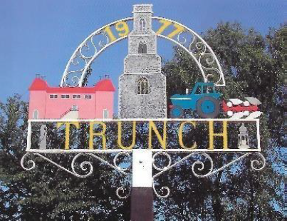
TRUNCH ANNUAL PARISH COUNCIL MEETING
TO BE HELD ON Sunday 6th MAY 2024 AT 6PM IN TRUNCH VILLAGE HALL, KNAPTON ROAD, TRUNCH, NR28 0QE

Councillors are summoned to, and members of the public and press are invited to attend.
Tracy Neave Clerk to Trunch Parish Council 2nd May 2024

AGENDA

- Apologies for absence and Chairman’s Welcome

- To confirm the Minutes of the Previous Meeting held on 10th May 2024

- Matters arising from the previous meeting. receive declarations of interest for items on the agenda and to consider any requests for dispensations

- Chairman’s Report

- Presentation

- Question and answers from the Public

- Date and time of next Annual Parish Meeting to be confirmed

- Refreshments

