Minutes of Trunch Parish Council Meeting
Held on Tuesday 11th June 2024 at 7pm

Present: Cllr. Richard MIles (Chair), Cllrs. David Burns, Jeremy Fielding David Houlton, Gaynor Houlton, , Barbara Wilson, District Cllr Peter Neatherway, Parish Clerk Tracy Neave, two Members of the Public, Mark Onassis Neighbourhood Watch Scheme Area Co-ordinator

- Apologies for absence: Cllr Paul Pearson

- Declarations of interest and requests for dispensations
Cllr Miles: Trunch Village Hall Committee and Allotment Holder, Cllr Wilson Allotment Holder

- Minutes of previous meeting held on 14th May 2024 were agreed and signed by the Chairman.

- Public Participation
  - County Councillor’s report: see appendix 1
  - District Councillor’s report: District Cllr. Neatherway explained that nutrient neutrality is an important issue being addressed by NNDC. One hundred housing applications are currently on hold whilst nutrient neutrality considerations are being investigated. Cllr Burns questioned the onus on affordable housing in respect of housing developments. Cllr Neatherway said local developments have a percentage of affordable housing and is trying to push for a higher commitment to affordable housing. NNDC are reviewing second homeowners and Council Tax.
  - Public Participation: A member of the public asked about the five-a-side goal posts: these have new nets. It was suggested tat there are a couple of benches on the Green. The overgrown hedges on North Walsham Road need cutting.
  - A representative from the Neighbourhood Watch Scheme gave a short talk on the scheme.

- Correspondence
5.1 NALC weekly updates
5.2 Rural Bulletin
5.3 NALC Chief Executive updates
5.4 Volunteer Extravaganza notice
5.5 Community Matters
5.6 Priorities meeting update
5.7 Norfolk Parish Training and Support Update
5.8. North Norfolk Community Transport – to be advertised in Mardle and Website

6. Matters arising from previous minutes
Covered in agenda items

7. New items
7.1 Clerk’s report
- GOV.uk emails in place and website has new address
- Planning and Cllr Neatherway have been contacted regarding the work at Wrights Loke. Cllr Neatherway advised he knows of no current application and will report back to the Council.
- Barclays debit card ordered
- Clerk completing final submissions for CILCA qualification and started FILCA qualification
- Highways advised that there is an objection to FP11 footpath and will be in touch regarding next steps
- Action plan advertised on website
- Signs for playing field organised
- Have phone call organised with St James Trust on Monday
- Grit bin survey for NCC – Cllr Miles to complete
- Playing field inspection to be organised
- Telephone meeting arranged with St James Trust

8. Periodic items
8.1 AGAR published on website along with Exercise of Public Rights

9. Finance
9.1 Bank statements and bank reconciliation (appendix 2) agreed with statements signed by Cllr Miles.
9.2 Income and Expenditure: see appendix 3
9.3 Payment schedule: agreed with one late payment to Cllr Pearson re DBS. See appendix 4

10. Highways
10.1 Highways Inspection Update and Actions: Update received to say that a camera team will be checking flooding at the social club this week with action to be undertaken soon. Overhanging hedge has been cut at the Pightel.
10.2 Cllr D Houlton reported that the overgrowing hedges at the allotments on Mundesley Road are the Parish Council’s responsibility following correspondence with the Diocese.

11. Playing Field
11.1 The results of the survey were discussed with costings being sourced for equipment. There will be further discussion once the costings are presented to Council with emphasis on what was suggested in the survey taking priority.
A working party is to be organised re cleaning play equipment.

12. Planning
13.1 New Planning Application: PO/24/0716 Erection of up to six dwellings (outline with
with details of access only): land off Bradfield Road, Trunch : object (TPC Planning
Committee decision as fell out of meeting timescale)
13.2 Decisions: PF/24/0592 Agricultural Barn, Brick Kiln Lane, Trunch: Approve full-
planning permission
13.3 Appeals: none

13 Footpaths
13.1 NNDC have been contacted regarding their schedule of work when hedges and grass are due to be cut.
Cllr Wilson raised the area around the pub and its poor state. Clerk to write letter to landlord.

14 To receive a report and consider any actions
14.1 Allotments: The Diocese say that the recommended work from the survey in 2023 has been completed however the Council are questioning how much work was completed. Cllr D Houlton will contact the Diocese to ask for clarification of work undertaken. It is the allotment tenants’ responsibility to maintain and tidy hedgerows and bushes.
14.2 Community Speed: The Speedwatch sessions are adjusted and organised in relation to data received from the Samsign device. Nine warning letters have been sent to recent speeding offenders.
14.3 Neighbourhood Plan: nothing to report (training in July)
14.4 Good Neighbour Scheme: Scheme recently advertised in ‘the Mardle’. The volunteer scheme is working well with currently 14 volunteers who have actioned 32 requests in the last three months. It was agreed to subscribe to the Community Action Network.
14.5 Warm Room/Community Café: nothing to report

15. General Parish Issues
Clerk on annual leave 1st to 5th July week
Neighbourhood Plan to be discussed at next meeting
Village green to be discussed at next meeting including TVS’s offer of financial support for bench and picnic table.

16. Date of next meeting 9th July 2024

Meeting closed at 20.16pm

Appendix 1
County Councillor’s Report, June 2024
As I mentioned in my last report, there’s not much going on at the moment at County Hall and now the General Election means there will be even less happening that I can report.
There have been some interesting items relating to debates about speed limits, flooding and support for children with disabilities and additional needs. But it is difficult to report those fully during the election period. So I will save those up for my July report which I will send out in the weekend of 6th/7th July.
The election does not stop me taking up issues on behalf of people or Parish Councils, so please do continue to contact me with issues you would like me to raise.
In case you are interested, here is the advice County Councillors have been given about what we can and cannot do in the election period. You’ll see it says that as individuals there are no restrictions on what we can say and do, only on what we can use council resources for. As an Independent, I don’t have any comment to make about the parties or candidates competing to be our local MP. But I use Council resources to write my report so I’d better steer clear of talking about debates at County Hall which tend to go along party lines.
From the Monitoring Officer – Pre-election Period
- We don’t have an election – does it apply to us?
Yes! The pre-election period applies across the country. The whole point of it is to prevent organisations like our own being seen to support (and by doing so affecting public support for) any political group.
2. When does pre-election start?
The pre-election period, as a matter of convention, commences on the date of the dissolution of parliament. However, Government has confirmed that, for the general election on 4th July 2024, the pre-election period will commence on Saturday 25th May 2024 at 1 minute after midnight. Please see Frequently asked questions | Local Government Association and the linked note is also very helpful. General election timetables 2024 - House of Commons Library (parliament.uk)
3. What is publicity ?
Publicity is defined as ‘any communication, in whatever form, addressed to the public at large or to a section of the public’.
The first question to ask is ‘could a reasonable person conclude that you are spending public money, or using public resources, in a way that might influence the outcome of the election?’ In other words, it must pass the ‘is it reasonable?’ test.
4. What are the practical implications?
For most people, nothing. Business as usual should carry on. Decisions can continue to be made, contracts let, social work, environmental work and the dazzling array of functions and duties undertaken every day is to continue. However, for those working in consultations, comms and with members should be careful of the following things:
- No political quotes. Usually, if we do something like open a new library or resource, the member for that portfolio will want to say something – rightly so, they have put in some hard work to get it done. However, in the pre-election period, if we are going to undertake comms, it should be a factual piece and an officer quote if necessary.
- Local authorities should not publish any publicity on controversial issues or report views or proposals in such a way that identifies them with any individual members or groups of members.
- We should not launch any new consultations. Unless it is a statutory duty or considered normal council business, such as budget consultations. Councils should consider carefully before starting any new consultations or publishing report findings from consultation exercises, which could be politically sensitive.
Please remember that the pre-election period is a restriction on Councils, not on individuals. Individual members can issue their own statements, talk to the media and say what they wish to in their personal capacity.
Please find some common questions asked by Councillors and responses below:
Question | Response
Can councillors issue their own press releases or talk to the media? | Councillors are free to talk to the media and issue press releases but must not use council resources to do so.
Can councillors write letters ‘for publication’ to their local newspaper? | Yes, as long as they don’t use council resources (such as staff) to help them do it. Can councillors still tweet or blog? Councillors can continue but must not use council resources (such as council twitter accounts, email accounts etc.) to do so.
Can councillors who are up for re-election to parliament refer to themselves as councillors in their public statements? | A person remains as a ‘councillor’ and can refer to themselves as such until they retire, their status as a parliamentary candidate does not change their councillor role.
Can councillors request to visit council establishments? | Generally reasonable requests by current members who are also candidates at the election to visit council establishments in the course of their council functions would be approved. Again, check local arrangements and any such visits must not be supported by the council’s media team or council officers.

Appendix 2
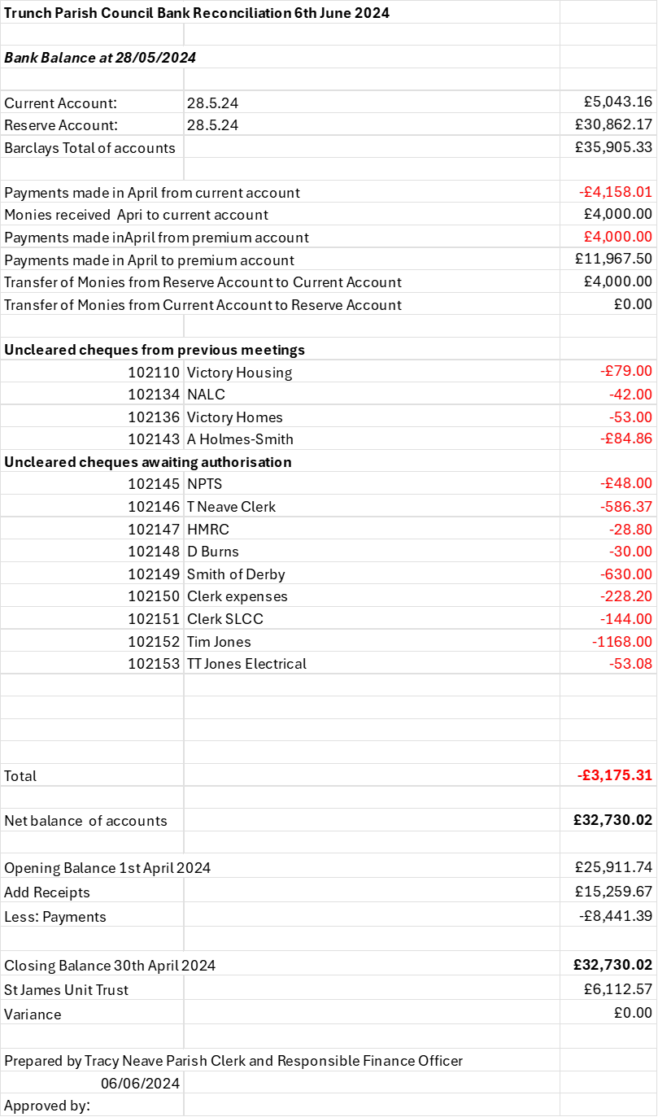

Appendix 3

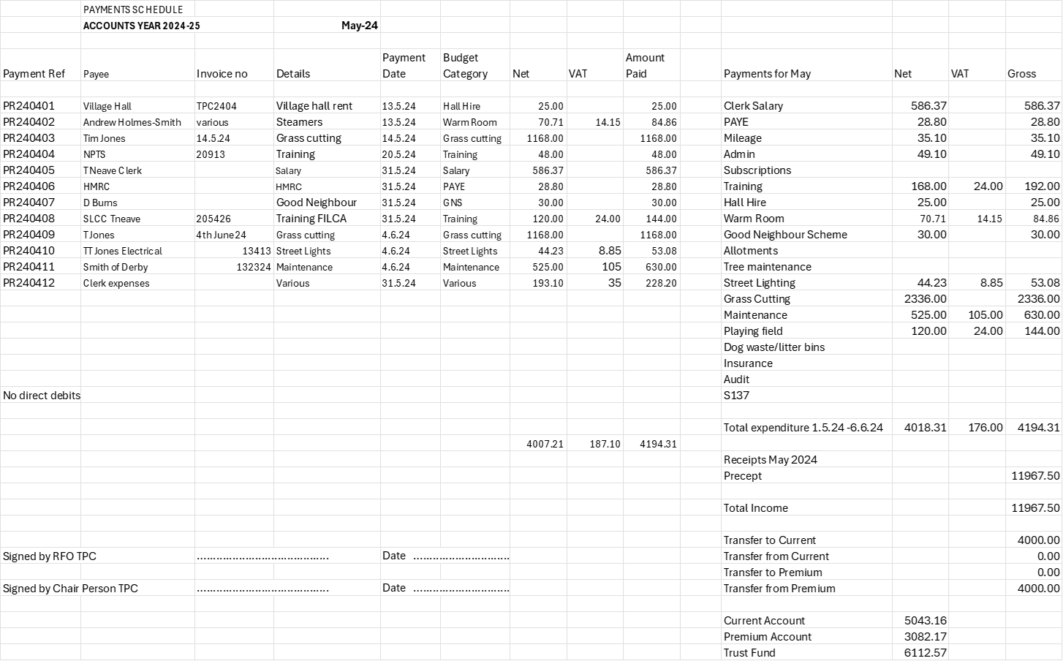
Appendix 4

