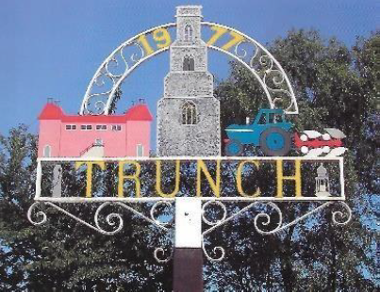
TRUNCH PARISH COUNCIL MEETING
TO BE HELD ON TUESDAY 11th November AT 7PM in the Village Hall Trunch

Councillors are summoned to, and members of the public and press are invited to attend. At item 12 the public will be invited to give their views and questions to the Parish Council on issues on the agenda or raise issues for the consideration of inclusion at future meetings. This item will generally be limited to a 30 minutes duration.
Tracy Neave Clerk to Trunch Parish Counvil 6th November 2025

AGENDA

- Apologies for absence

- To receive declarations of interest for items on the agenda and to consider any requests
for dispensation

- To confirm the Minutes of the meeting held on 14th October 2025

4. County and District Councillors Reports
4.1 County Councillors report
4.2 District Councillors report

5. Correspondence
5.1 Trodpath and speed awareness communication Cllr Maxfield/Cllr Burns
5.2 Allotment lease from Diocese with rental increase, to agree Heads of Term
5.3 Delay in receiving Parish Precept taxbase figure 2026/27

6. Matters Arising from previous minutes and new items.
6.1 Assertion 10 AGAR to be carried over to new year.
6.2 Energy Club

7. Finance and Administration
7.1 Bank statements and bank reconciliation
7.2 Payment schedule:
7.3 Proposed donation to Norfolk Pond Society
7.4 Budget proposals in readiness for December meeting

8 Highways
8.1 To receive any Highways matters and agree actions

9. Playing Field: to receive any playing field matters and agree actions including working
group recommendations
9.1 Update on pétanque court
9.3 Feedback from playground inspection training

10. Planning
10.1 New Planning Applications: None received
10.2 Decisions: None received
10.3 Appeals: None received

11. To receive a report and consider any actions
11.1 Allotments
11.2 Community Speed
11.3 Neighbourhood Plan including progress report and policies
11.4 Good Neighbour Scheme
11.5 Environmental Group
11.6 Footpaths

12. Public Participation

13. General Parish Issues (for information only)

14. Date of next Parish Council Meeting 9th December 2025 7pm Trunch Village Hall

15. Exclusion of the Press and Public under the Public Bodies (Admission to Meetings) Act
1960 to discuss the following matter:
- To discuss and agree steps in recruitment of Parish Clerk and Responsible Finance
Officer.

